R version 4.5.1 (2025-06-13) -- "Great Square Root"

Copyright (C) 2025 The R Foundation for Statistical Computing

Platform: aarch64-apple-darwin20

R is free software and comes with ABSOLUTELY NO WARRANTY.

You are welcome to redistribute it under certain conditions.

Type 'license()' or 'licence()' for distribution details.

Natural language support but running in an English locale

R is a collaborative project with many contributors.

Type 'contributors()' for more information and

'citation()' on how to cite R or R packages in publications.

Type 'demo()' for some demos, 'help()' for on-line help, or

'help.start()' for an HTML browser interface to help.

Type 'q()' to quit R.

> #Install packages

> install.packages("tidyverse")

trying URL 'https://cran.rstudio.com/bin/macosx/big-sur-arm64/contrib/4.5/tidyverse_2.0.0.tgz'

Content type 'application/x-gzip' length 428840 bytes (418 KB)

==================================================

downloaded 418 KB

The downloaded binary packages are in

/var/folders/fw/6k7s8nms1s99pt9xyfgb3dsh0000gp/T//RtmptWTW2E/downloaded_packages

> install.packages("correlation")

trying URL 'https://cran.rstudio.com/bin/macosx/big-sur-arm64/contrib/4.5/correlation_0.8.8.tgz'

Content type 'application/x-gzip' length 519041 bytes (506 KB)

==================================================

downloaded 506 KB

The downloaded binary packages are in

/var/folders/fw/6k7s8nms1s99pt9xyfgb3dsh0000gp/T//RtmptWTW2E/downloaded_packages

> install.packages("gridExtra")

trying URL 'https://cran.rstudio.com/bin/macosx/big-sur-arm64/contrib/4.5/gridExtra_2.3.tgz'

Content type 'application/x-gzip' length 1105625 bytes (1.1 MB)

==================================================

downloaded 1.1 MB

The downloaded binary packages are in

/var/folders/fw/6k7s8nms1s99pt9xyfgb3dsh0000gp/T//RtmptWTW2E/downloaded_packages

> install.packages("ppcor")

trying URL 'https://cran.rstudio.com/bin/macosx/big-sur-arm64/contrib/4.5/ppcor_1.1.tgz'

Content type 'application/x-gzip' length 29252 bytes (28 KB)

==================================================

downloaded 28 KB

The downloaded binary packages are in

/var/folders/fw/6k7s8nms1s99pt9xyfgb3dsh0000gp/T//RtmptWTW2E/downloaded_packages

> install.packages("cocor")

trying URL 'https://cran.rstudio.com/bin/macosx/big-sur-arm64/contrib/4.5/cocor_1.1-4.tgz'

Content type 'application/x-gzip' length 1288537 bytes (1.2 MB)

==================================================

downloaded 1.2 MB

The downloaded binary packages are in

/var/folders/fw/6k7s8nms1s99pt9xyfgb3dsh0000gp/T//RtmptWTW2E/downloaded_packages

> library(tidyverse)

── Attaching core tidyverse packages ────────────────────────────────────────────────────────── tidyverse 2.0.0 ──

✔ dplyr 1.1.4 ✔ readr 2.1.5

✔ forcats 1.0.0 ✔ stringr 1.5.1

✔ ggplot2 3.5.2 ✔ tibble 3.3.0

✔ lubridate 1.9.4 ✔ tidyr 1.3.1

✔ purrr 1.1.0

── Conflicts ──────────────────────────────────────────────────────────────────────────── tidyverse_conflicts() ──

✖ dplyr::filter() masks stats::filter()

✖ dplyr::lag() masks stats::lag()

ℹ Use the conflicted package to force all conflicts to become errors

> library(correlation)

> library(gridExtra)

Attaching package: ‘gridExtra’

The following object is masked from ‘package:dplyr’:

combine

> library(ppcor)

Loading required package: MASS

Attaching package: ‘MASS’

The following object is masked from ‘package:dplyr’:

select

> library(cocor)

> #Viewing data

> correlation_data <- read_csv("CorrelationsData.csv")

> setwd("~/Royal Holloway Dropbox/Beatrice Hayes/Beatrice Hayes/Work/Teaching Fellow/2025-26/PS5302/Lab Workshops")

> #Viewing data

> correlation_data <- read_csv("CorrelationsData.csv")

Rows: 200 Columns: 49

── Column specification ──────────────────────────────────────────────────────────────────────────────────────────

Delimiter: ","

dbl (49): Age, Gender, CRS_1, CRS_2, CRS_3, CRS_4, CRS_5, MFQ_1, MFQ_2, MFQ_3, MFQ_4, MFQ_5, MFQ_6, MFQ_7, MFQ...

ℹ Use `spec()` to retrieve the full column specification for this data.

ℹ Specify the column types or set `show_col_types = FALSE` to quiet this message.

> view(correlation_data)

> summary(correlation_data)

Age Gender CRS_1 CRS_2 CRS_3 CRS_4 CRS_5

Min. :18.00 Min. :0.00 Min. :1.000 Min. :1.000 Min. :1.00 Min. :1.000 Min. :1.0

1st Qu.:27.00 1st Qu.:0.00 1st Qu.:3.000 1st Qu.:3.000 1st Qu.:3.00 1st Qu.:3.000 1st Qu.:3.0

Median :34.50 Median :1.00 Median :3.000 Median :4.000 Median :4.00 Median :4.000 Median :3.0

Mean :34.17 Mean :0.52 Mean :3.455 Mean :3.575 Mean :3.68 Mean :3.475 Mean :3.4

3rd Qu.:39.25 3rd Qu.:1.00 3rd Qu.:4.000 3rd Qu.:4.000 3rd Qu.:4.25 3rd Qu.:4.000 3rd Qu.:4.0

Max. :62.00 Max. :1.00 Max. :5.000 Max. :5.000 Max. :5.00 Max. :5.000 Max. :5.0

MFQ_1 MFQ_2 MFQ_3 MFQ_4 MFQ_5 MFQ_6 MFQ_7

Min. :1.00 Min. :1.000 Min. :1.00 Min. :1.000 Min. :1.00 Min. :1.000 Min. :1.000

1st Qu.:2.00 1st Qu.:2.000 1st Qu.:2.00 1st Qu.:2.000 1st Qu.:2.00 1st Qu.:2.000 1st Qu.:2.000

Median :3.00 Median :3.000 Median :3.00 Median :3.000 Median :3.00 Median :3.000 Median :3.000

Mean :2.99 Mean :3.005 Mean :2.98 Mean :2.945 Mean :2.91 Mean :3.065 Mean :3.025

3rd Qu.:4.00 3rd Qu.:4.000 3rd Qu.:4.00 3rd Qu.:4.000 3rd Qu.:4.00 3rd Qu.:4.000 3rd Qu.:4.000

Max. :5.00 Max. :5.000 Max. :5.00 Max. :5.000 Max. :5.00 Max. :5.000 Max. :5.000

MFQ_8 MFQ_9 MFQ_10 MFQ_11 MFQ_12 MFQ_13 MFQ_14

Min. :1.00 Min. :1.000 Min. :1.00 Min. :1 Min. :1.000 Min. :1.000 Min. :1.00

1st Qu.:2.00 1st Qu.:2.000 1st Qu.:2.00 1st Qu.:2 1st Qu.:2.000 1st Qu.:2.000 1st Qu.:2.00

Median :3.00 Median :3.000 Median :3.00 Median :3 Median :3.000 Median :3.000 Median :3.00

Mean :3.04 Mean :3.035 Mean :2.97 Mean :3 Mean :2.875 Mean :3.005 Mean :2.92

3rd Qu.:4.00 3rd Qu.:4.000 3rd Qu.:4.00 3rd Qu.:4 3rd Qu.:4.000 3rd Qu.:4.000 3rd Qu.:4.00

Max. :5.00 Max. :5.000 Max. :5.00 Max. :5 Max. :5.000 Max. :5.000 Max. :5.00

MFQ_15 MFQ_16 MFQ_17 MFQ_18 MFQ_19 MFQ_20 MFQ_21

Min. :1.000 Min. :1.000 Min. :1.000 Min. :1.00 Min. :1.000 Min. :1.00 Min. :1.000

1st Qu.:2.000 1st Qu.:2.000 1st Qu.:2.000 1st Qu.:3.00 1st Qu.:2.000 1st Qu.:2.00 1st Qu.:2.000

Median :3.000 Median :3.000 Median :3.000 Median :3.00 Median :3.000 Median :3.00 Median :3.000

Mean :3.045 Mean :2.905 Mean :2.915 Mean :3.11 Mean :2.935 Mean :3.05 Mean :2.995

3rd Qu.:4.000 3rd Qu.:4.000 3rd Qu.:4.000 3rd Qu.:4.00 3rd Qu.:4.000 3rd Qu.:4.00 3rd Qu.:4.000

Max. :5.000 Max. :5.000 Max. :5.000 Max. :5.00 Max. :5.000 Max. :5.00 Max. :5.000

MFQ_22 MFQ_23 MFQ_24 MFQ_25 MFQ_26 MFQ_27 MFQ_28

Min. :1.00 Min. :1.00 Min. :1.00 Min. :1.000 Min. :1.000 Min. :1.00 Min. :1.000

1st Qu.:2.00 1st Qu.:2.00 1st Qu.:2.00 1st Qu.:2.000 1st Qu.:2.000 1st Qu.:2.00 1st Qu.:2.000

Median :3.00 Median :3.00 Median :3.00 Median :3.000 Median :3.000 Median :3.00 Median :3.000

Mean :2.84 Mean :2.88 Mean :2.93 Mean :2.965 Mean :3.045 Mean :2.98 Mean :3.045

3rd Qu.:3.25 3rd Qu.:4.00 3rd Qu.:4.00 3rd Qu.:4.000 3rd Qu.:4.000 3rd Qu.:4.00 3rd Qu.:4.000

Max. :5.00 Max. :5.00 Max. :5.00 Max. :5.000 Max. :5.000 Max. :5.00 Max. :5.000

MFQ_29 MFQ_30 SMDS_1 SMDS_2 SMDS_3 SMDS_4 SMDS_5

Min. :1.000 Min. :1.00 Min. :1.00 Min. :1.00 Min. :1.00 Min. :1.0 Min. :1.000

1st Qu.:2.000 1st Qu.:2.00 1st Qu.:3.00 1st Qu.:3.00 1st Qu.:3.00 1st Qu.:3.0 1st Qu.:3.000

Median :3.000 Median :3.00 Median :3.00 Median :3.00 Median :3.00 Median :3.0 Median :3.000

Mean :3.105 Mean :3.08 Mean :3.11 Mean :3.09 Mean :3.13 Mean :3.1 Mean :3.105

3rd Qu.:4.000 3rd Qu.:4.00 3rd Qu.:4.00 3rd Qu.:4.00 3rd Qu.:4.00 3rd Qu.:4.0 3rd Qu.:4.000

Max. :5.000 Max. :5.00 Max. :5.00 Max. :5.00 Max. :5.00 Max. :5.0 Max. :5.000

SMDS_6 SMDS_7 SMDS_8 SMDS_9 SMDS_10 SMDS_11 SMDS_12

Min. :1.000 Min. :1.00 Min. :1.00 Min. :1.00 Min. :1.000 Min. :1.00 Min. :1.000

1st Qu.:3.000 1st Qu.:3.00 1st Qu.:3.00 1st Qu.:3.00 1st Qu.:3.000 1st Qu.:2.00 1st Qu.:3.000

Median :3.000 Median :3.00 Median :3.00 Median :3.00 Median :3.000 Median :3.00 Median :3.000

Mean :3.095 Mean :3.11 Mean :3.11 Mean :3.11 Mean :3.095 Mean :3.09 Mean :3.085

3rd Qu.:4.000 3rd Qu.:4.00 3rd Qu.:4.00 3rd Qu.:4.00 3rd Qu.:4.000 3rd Qu.:4.00 3rd Qu.:4.000

Max. :5.000 Max. :5.00 Max. :5.00 Max. :5.00 Max. :5.000 Max. :5.00 Max. :5.000

>

> #Cleaning - defining variables, calculating means.

> correlation_data$CRSmean <- rowMeans(correlation_data[, 3:7], na.rm = TRUE)

> correlation_data$MFQmean <- rowMeans(correlation_data[, 8:37], na.rm = TRUE)

> correlation_data$SMDSmean <- rowMeans(correlation_data[, 38:49], na.rm = TRUE)

> correlation_data$Age <- as.numeric(correlation_data$Age)

> correlation_data$Gender <- as.factor(correlation_data$Gender)

> correlation_data$CRSmean <- as.numeric(correlation_data$CRSmean)

> correlation_data$MFQmean <- as.numeric(correlation_data$MFQmean)

> correlation_data$SMDSmean <- as.numeric(correlation_data$SMDSmean)

> > #Cleaning - defining variables, calculating means.

> correlation_data$CRSmean <- rowMeans(correlation_data[, 3:7], na.rm = TRUE)

> correlation_data$MFQmean <- rowMeans(correlation_data[, 8:37], na.rm = TRUE)

> correlation_data$SMDSmean <- rowMeans(correlation_data[, 38:49], na.rm = TRUE)

> correlation_data$Age <- as.numeric(correlation_data$Age)

> correlation_data$Gender <- as.factor(correlation_data$Gender)

> correlation_data$CRSmean <- as.numeric(correlation_data$CRSmean)

> correlation_data$MFQmean <- as.numeric(correlation_data$MFQmean)

> correlation_data$SMDSmean <- as.numeric(correlation_data$SMDSmean)

> #Means

> mean_age <- mean(correlation_data$Age)

> print(mean_age)

[1] 34.17

> mean_CRS <- mean(correlation_data$CRSmean)

> print(mean_CRS)

[1] 3.517

> mean_MFQ <- mean(correlation_data$MFQmean)

> print(mean_MFQ)

[1] 2.986333

> mean_SMDS <- mean(correlation_data$SMDSmean)

> print(mean_SMDS)

[1] 3.1025

> > #Scatterplots

> plot1 <- ggplot(correlation_data, aes(x = Age, y = SMDSmean)) +

+ geom_point() +

+ geom_smooth(method = "lm",

+ se = FALSE) +

+ theme_classic()

> plot2 <- ggplot(correlation_data, aes(x = CRSmean, y = SMDSmean)) +

+ geom_point() +

+ geom_smooth(method = "lm",

+ se = FALSE) +

+ theme_classic()

>

> plot3 <- ggplot(correlation_data, aes(x = MFQmean, y = SMDSmean)) +

+ geom_point() +

+ geom_smooth(method = "lm",

+ se = FALSE) +

+ theme_classic()

>

> grid.arrange(plot1, plot2, plot3, nrow = 2, ncol = 2)

`geom_smooth()` using formula = 'y ~ x'

`geom_smooth()` using formula = 'y ~ x'

`geom_smooth()` using formula = 'y ~ x'

>

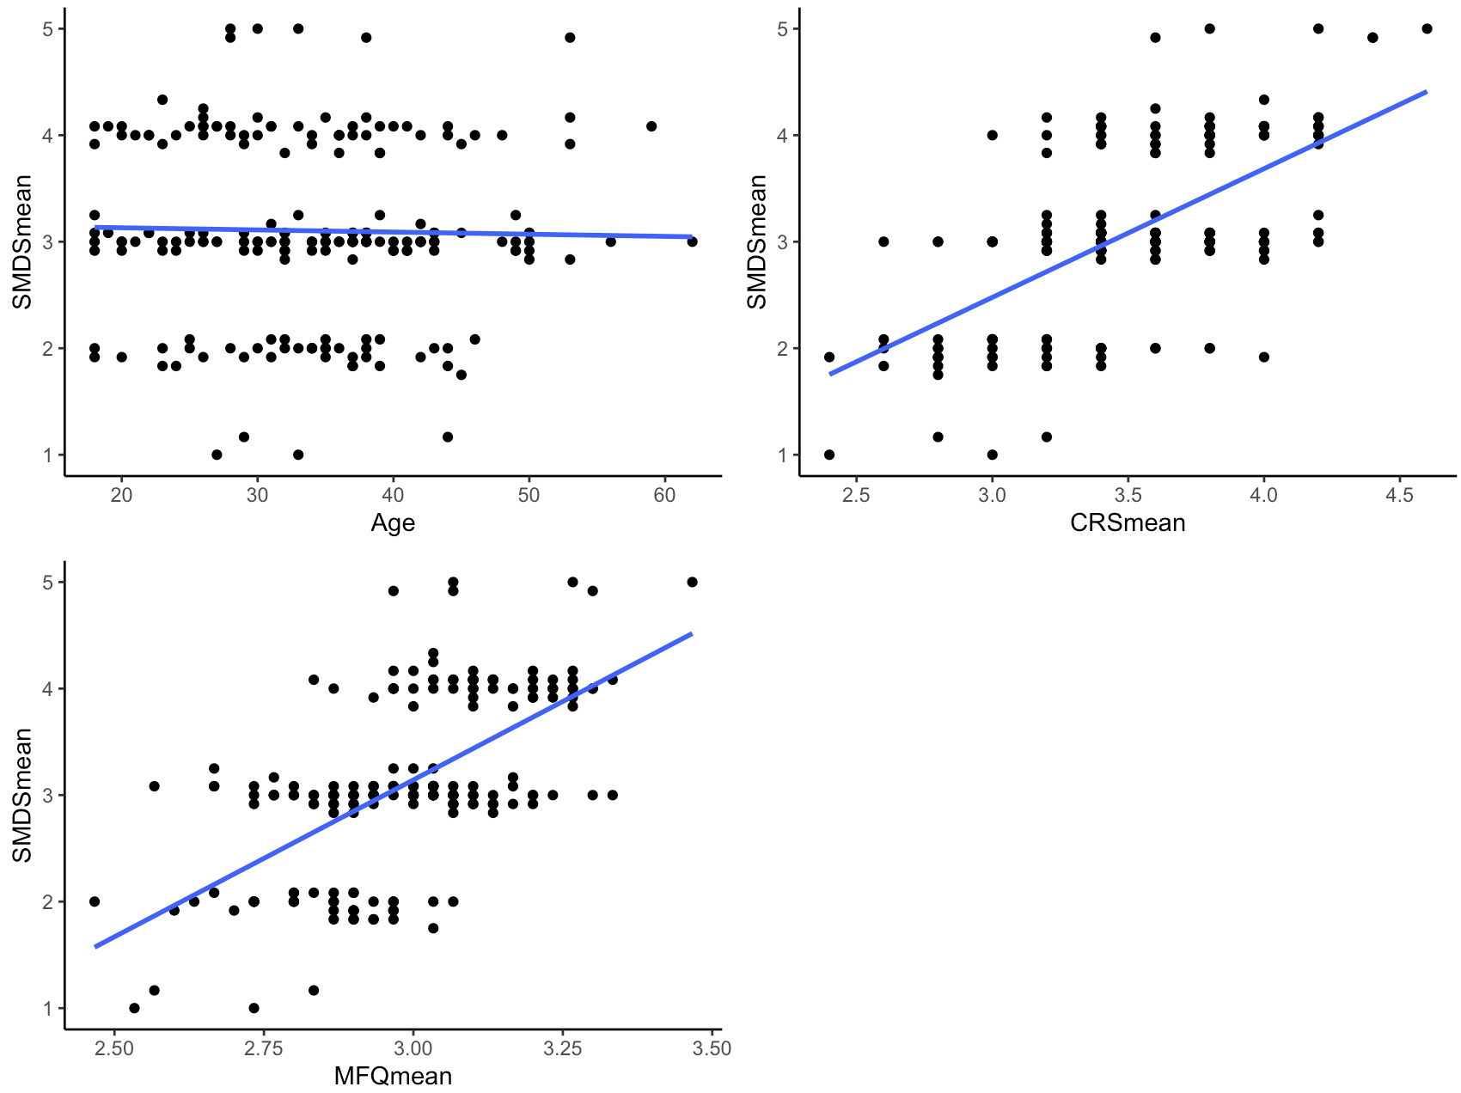

> #Pearsons Correlations

> correlation_data %>%

+ dplyr::select(Age, CRSmean, MFQmean, SMDSmean) %>%

+ correlation(p_adjust = "none")

# Correlation Matrix (pearson-method)

Parameter1 | Parameter2 | r | 95% CI | t(198) | p

------------------------------------------------------------------------

Age | CRSmean | -0.01 | [-0.15, 0.13] | -0.15 | 0.880

Age | MFQmean | -1.29e-03 | [-0.14, 0.14] | -0.02 | 0.986

Age | SMDSmean | -0.02 | [-0.16, 0.12] | -0.31 | 0.756

CRSmean | MFQmean | -0.01 | [-0.15, 0.13] | -0.18 | 0.856

CRSmean | SMDSmean | 0.61 | [ 0.52, 0.69] | 10.93 | < .001***

MFQmean | SMDSmean | 0.61 | [ 0.52, 0.69] | 10.93 | < .001***

p-value adjustment method: none

Observations: 200

> #Partial Correlations

> pcor.test(correlation_data$CRSmean, correlation_data$MFQmean,

+ correlation_data$Age,

+ method = "pearson")

estimate p.value statistic n gp Method

1 -0.01295497 0.8558898 -0.181847 200 1 pearson

> #Partial Correlations

> pcor.test(correlation_data$CRSmean, correlation_data$MFQmean,

+ correlation_data$Age,

+ method = "pearson")

estimate p.value statistic n gp Method

1 -0.01295497 0.8558898 -0.181847 200 1 pearson

>

> pcor.test(correlation_data$CRSmean, correlation_data$SMDSmean,

+ correlation_data$Age,

+ method = "pearson")

estimate p.value statistic n gp Method

1 0.6133849 5.916006e-22 10.90079 200 1 pearson

>

> pcor.test(correlation_data$MFQmean, correlation_data$SMDSmean,

+ correlation_data$Age,

+ method = "pearson")

estimate p.value statistic n gp Method

1 0.6134112 5.885732e-22 10.90153 200 1 pearson

>

> #Comparing Correlations

> male <- correlation_data[correlation_data$Gender == "0", ]

> female <- correlation_data[correlation_data$Gender == "1", ]

>

> cor.test(male$MFQmean, male$CRSmean,

+ method = "pearson")

Pearson's product-moment correlation

data: male$MFQmean and male$CRSmean

t = -0.092253, df = 94, p-value = 0.9267

alternative hypothesis: true correlation is not equal to 0

95 percent confidence interval:

-0.2096009 0.1913361

sample estimates:

cor

-0.009514784

> cor.test(female$MFQmean, female$CRSmean,

+ method = "pearson")

Pearson's product-moment correlation

data: female$MFQmean and female$CRSmean

t = -0.13703, df = 102, p-value = 0.8913

alternative hypothesis: true correlation is not equal to 0

95 percent confidence interval:

-0.2056181 0.1794900

sample estimates:

cor

-0.01356718

> cor.test(female$MFQmean, female$SMDSmean,

+ method = "pearson")

Pearson's product-moment correlation

data: female$MFQmean and female$SMDSmean

t = 8.2125, df = 102, p-value = 7.057e-13

alternative hypothesis: true correlation is not equal to 0

95 percent confidence interval:

0.4989348 0.7342717

sample estimates:

cor

0.6309004

> cor.test(female$SMDSmean, female$CRSmean,

+ method = "pearson")

Pearson's product-moment correlation

data: female$SMDSmean and female$CRSmean

t = 7.7376, df = 102, p-value = 7.529e-12

alternative hypothesis: true correlation is not equal to 0

95 percent confidence interval:

0.4707121 0.7168001

sample estimates:

cor

0.6081677

>

> cocor.indep.groups(0.5999553, 0.6081677, 92, 100)

Results of a comparison of two correlations based on independent groups

Comparison between r1.jk = 0.6 and r2.hm = 0.6082

Difference: r1.jk - r2.hm = -0.0082

Group sizes: n1 = 92, n2 = 100

Null hypothesis: r1.jk is equal to r2.hm

Alternative hypothesis: r1.jk is not equal to r2.hm (two-sided)

Alpha: 0.05

fisher1925: Fisher's z (1925)

z = -0.0881, p-value = 0.9298

Null hypothesis retained

zou2007: Zou's (2007) confidence interval

95% confidence interval for r1.jk - r2.hm: -0.1941 0.1745

Null hypothesis retained (Interval includes 0)

>

> plot_cc <- ggplot(correlation_data, aes(x = CRSmean, y = MFQmean, colour = Gender)) +

+ geom_point(aes(shape = Gender)) +

+ geom_smooth(aes(linetype = Gender), method = "lm", se = FALSE) +

+ labs(title = "Religiosity vs Morality by Gender",

+ x = "Religiosity",

+ y = "Morality") +

+ theme_classic() +

+ scale_color_manual(values = c("0" = "grey", "1" = "black ")) +

+ scale_linetype_manual(values = c("0" = "solid", "1" = "dashed")) +

+ scale_shape_manual(values = c("0" = 16, "1" = 3))

> print(plot_cc)

`geom_smooth()` using formula = 'y ~ x'

>